Joseph Arbolino
Part 1
- www.notarealdomainformalware.com
- A GET request.
- Full HTTP Request:
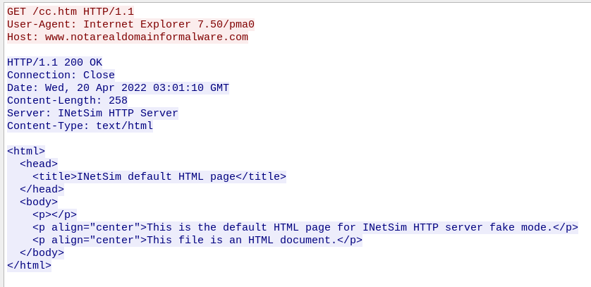
- The program prints “Not a valid command”.

- There are 5 valid commands.

- Each command is represented by a char of value 97 – 101. This is ascii ‘a’ – ‘e’. The program accepts these ascii characters as valid commands.
  - CreateDirectoryA – Creates a directory C:\Temp
  - CopyFileA – Copies C:\Temp\cc.exe to the directory
  - DeleteFileA – Deletes C:\Temp\cc.exe from the directory
  - RegOpenKeyExA – Executes the cc.exe file.
  - Sleep – Sleeps the program for 100000 milliseconds.
